
  - GROWER UPDATE: SEPTEMBER 2026

LATEST NEWS

AgConnex secures $4 million NSW grant co-funding to further upgrade its rail loading, storage and processing capability at Wumbulgal.
Read the full story here.

🚜 THIS MONTH AT A GLANCE

Market Snapshot
Commodity | Nearby Price ($/t) | Month Change ($/t) | Market Tone
APW Wheat | $350 | -$5 | Softer
ASW Wheat | $345 | -$5 | Softer
Barley | $305 | $5 | Neutral
Cotton Seed | $550 | $10 | Neutral
📈 Wheat: The Black Sea remains a key focus for wheat markets, with renewed Russia, Ukraine peace talks creating short-term price pressure as traders assess the potential for improved export flows. However, infrastructure and shipping risks remain, keeping execution risk in the market.
Globally, wheat supply remains relatively comfortable, although tighter production across some major exporters is providing support to prices. Closer to home, the outlook is increasingly split. Victoria is forecast to produce 11.3 Mt of winter crops, marginally above its previous record, while South Australia is forecast at 11.3 Mt, its second-highest on record. Strong soil moisture and advanced crops are supporting excellent yield potential across the southern states. In contrast, northern NSW and Queensland continue to face below-average moisture and weaker yield prospects.
📈 Barley: Northern barley markets have remained firm, with Downs delivered values holding around $410–$412/t despite volatility in wheat. Strong feedlot demand continues to support the market, with cattle on feed reaching 1.66 million head at 93% utilisation. The Downs has been drawing significant volumes of barley from our area over the past three months, but this movement is becoming increasingly difficult as fuel price volatility pushes freight rates higher and reduces the advantage of moving grain north.
Southern markets have moved in the opposite direction, with Melbourne and Geelong values easing towards $315/t as improving crop prospects encourage grower selling. ABARES forecasts Victorian barley production up 10% to 3.40Mt and South Australian production up 35% to 2.90Mt, adding weight to the southern balance sheet.

🌧️ Rainfall Snapshot
Location | Rainfall (mm) YTD 13/07/26 | Rainfall (mm)  YTD 15/08/26 | Rainfall (mm)  YTD 16/09/2026
Griffith | 127 | 158.8 | 174.4
Temora | 324 | 379.4 | 444
Moree | 163 | 210.6 | 249
Gunnedah | 209 | 248.2 | 280
Forbes | 327 | 390 | 422
Swan Hill | 271 | 315.4 | 351
Mildura | 255.5 | 323 | 345
Rainfall through August and early September has provided a useful boost across most districts, with YTD totals reaching 444 mm at Temora, 422 mm at Forbes, 351 mm at Swan Hill and 345 mm at Mildura. Griffith remains the driest location at just 174.4 mm YTD, well below the other districts, highlighting the significant variability in seasonal conditions. Moree and Gunnedah sit at 249 mm and 280 mm respectively. Recent falls should support crop development and soil moisture where received, but growers in the drier areas will need to closely monitor moisture reserves, crop water use and yield potential. Timely rain through spring will remain important, particularly around Griffith.

SITE & OPERATIONS UPDATE

What’s Happening Across AgConnex
It’s all happening across AgConnex as we gear up for the 26/27 harvest season. New machinery is hitting the ground, construction is underway, our people are building their skills and plenty of work is happening behind the scenes to get our sites harvest-ready. Here’s a look at what’s been happening across the network this month .
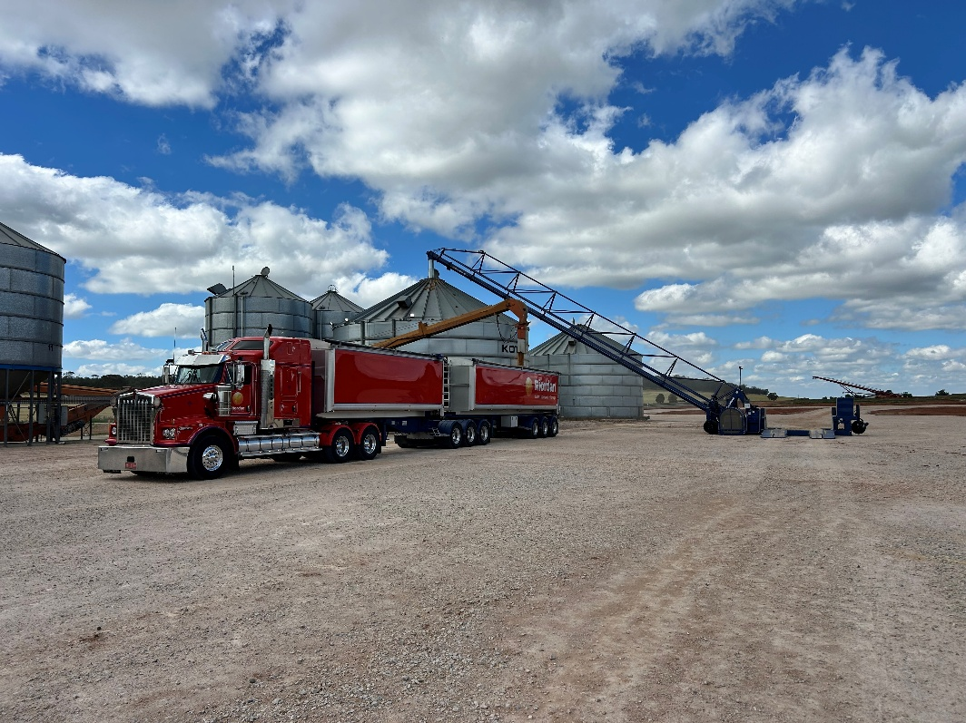
Our new Grainline self-propelled drive-over has arrived at Wumbulgal
- And it’s already hard at work! Capable of moving up to 1,000 tonnes per hour, the new drive-over will give our team greater flexibility around the site and help keep grain moving efficiently during busy receival periods.

- A big congratulations to Rebecca Conway, who has officially completed her Authorised Officer training and is now fully accredited! Bec’s accreditation adds another qualified AO to the AgConnex team and strengthens our capability to support our Wumbulgal export programs. It’s great to see another member of the team building their skills and taking on an important role within our export operations. Well done, Bec!
- There’s plenty happening around Wumbulgal, with MEDLOG now commencing construction of its new rail siding and associated building works on site. It’s an exciting period of development for the site, but it also means more construction activity, machinery and vehicle movements as we head towards harvest. With harvest traffic soon to join the mix, we’ve made some important changes to how vehicles move through Wumbulgal.
- If you’re heading into Wumbulgal, take note – our traffic flow has changed. A new Traffic Management Plan is now in place and will remain in effect throughout harvest while construction works continue. The visitor car park and farmer sample drop-off point have been relocated, and there are now two designated throughput lanes in and out of the site. Whether you’re a grower, carrier, contractor or visitor, please follow the new traffic routes and on-site signage when entering and moving around the site. Thanks for working with us to keep traffic moving safely and efficiently during what’s shaping up to be a very busy harvest.
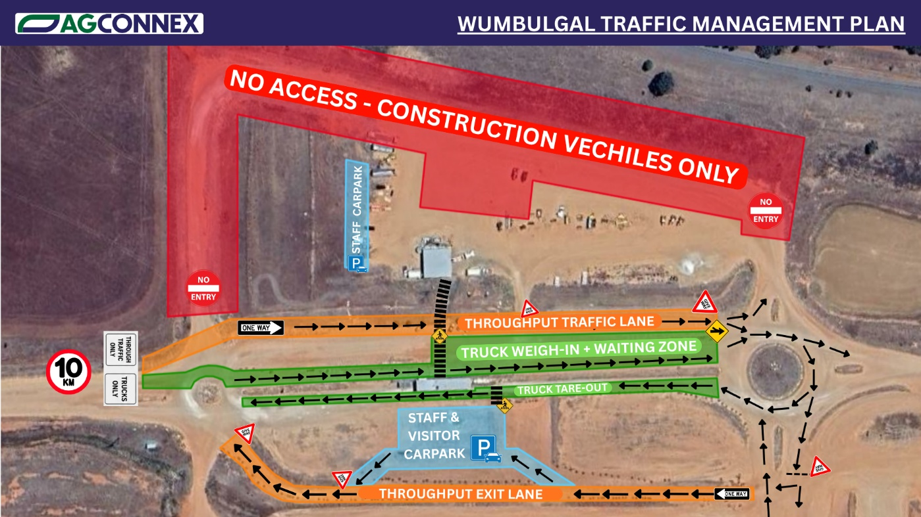
👉 Check out the Wumbulgal Traffic Management Map below before your next visit so you know where to go.

It’s not just Wumbulgal that’s busy. Our teams at Benerembah, Carrathool and Coleambally are getting stuck into harvest preparation, with maintenance, bunker preparation, tarp work, machinery checks, site clean-ups and infrastructure inspections underway. There’s plenty still happening behind the scenes, but the goal is simple – have our sites ready to go when the first loads of the 2026/27 harvest start rolling through the gates. Bring on harvest!

📊 MARKET OPPORTUNITY OF THE MONTH

AgConnex Insight: Consider Your 2026/27 Grain Marketing Strategy
With harvest approaching, now is a good time to review current 2026/27 season bids and consider whether locking in a portion of your expected production could be right for your business.
Prices have strengthened recently, particularly in wheat, with concerns around Black Sea supply and ongoing geopolitical tensions providing support to global markets. The Australian market has followed this movement, creating improved opportunities for growers to lock in new crop pricing. However, any resolution or easing of the situation in the Black Sea could see some of these recent gains unwind, highlighting the importance of considering price risk while current opportunities are available.
Selling some new crop ahead of harvest can provide greater price certainty and reduce the risk of having to sell your entire crop at harvest, while still allowing you to retain some grain in case market opportunities improve later in the season. There’s no need to sell everything taking a staged approach can help spread your price risk and provide flexibility as the season progresses.
AgConnex provides daily price updates across all four of our sites, along with delivered market opportunities as they become available. If you’re not currently receiving our daily price text messages, please contact the AgConnex team to be added to our list.

👉 Talk to our team

🧠 GRAIN KNOWLEDGE HUB

Quick Reminder
Harvest is just around the corner, so now is the time to get organised and avoid any last-minute issues. If you haven’t updated your NGR details, make sure this is done before harvest. Check that every truck has a valid NGR card, and if you plan on using contractors, make sure you have enough cards available for their trucks as well.
It’s also a good time to have a current list of your crop varieties ready and confirm the weight limits for your trucks and trailers combinations. Having these details confirmed ahead of harvest will help ensure an efficient harvest operation and minimise unnecessary delays during the busy period.
👉 Talk to our team

AgConnex – Your Trusted Grain Connection
Connecting regional grain producers with storage, handling, transport and end-user markets across the Riverina. For more details and pricing, please contact:
Geoff Barker, CEO/Grain Trader: 0437 950 906
Archie Triggs, Grain Merchant: 0448 893 358
Carl Robinson Operation Manger: 0418 584 266
Office: 02 6962 9500

Email info@agconnex.com.au
Website agconnex.com.au

